Drumnamoe Nursery School

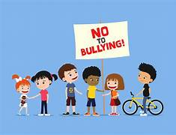

Anti- Bullying Policy

Reviewed on: _____________

Next Review: _____________

Signed (Chairperson): ___________

Anti-Bullying Policy

Statement of Intent

In Drumnamoe Nursery School we aim to provide a safe, secure, happy learning environment for our children, staff and extended members of our school community. We are opposed to bullying in any form, as it is contrary to the values and principles we all work, and live by. Everyone has the right to learn and work in a secure and caring school, and therefore we each have a responsibility to contribute, in whatever way we can, to the protection and maintenance of such an environment. Our approach to implementing our Anti- Bullying Policy accounts for each individual pupil’s developmental age or capacity to understand the impact of their behaviour.

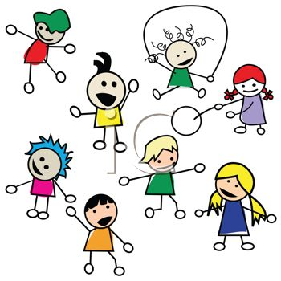

Definition

The Northern Ireland Anti-Bullying Forum defines bullying as the repeated use of power by one or more persons intentionally to harm, hurt or adversely affect the rights or needs of another or others. The Addressing Bullying in Schools Act (2016) states that bullying includes, but is not limited to: the repeated use of any verbal, written or electronic communication; any other act; or any combination of those by a pupil or group of pupils against another pupil or group of pupils, with the intention of causing physical or emotional harm to that pupil or group of pupils.
On the 30th November 2015, Education Minister Mr John O Dowd introduced the “Addressing Bullying in Schools’ Bill” to the N I assembly. The legislation provided a legal definition of bullying, introduced a requirement for schools to record all incidents of bullying, and required Boards of Governors to take direct responsibility for developing and monitoring the effectiveness of An Anti -Bullying policy and its practice in schools.
What is Bullying?
Bullying can be defined as behaviour that is unwanted and aggressive, which involves a real or a perceived power imbalance. The action of bullying is:
- Repeated [a one –off incident will not count]
- intended to hurt someone either physically or emotionally
- often aimed at certain groups, eg because of their race, religion, gender or sexual orientation
If undetected or unchecked, bullying can be profoundly damaging to the person experiencing bullying behaviours, both in the short and longer term, emotionally or physically or both, and it can seriously disrupt or impair the person’s capacity to learn and develop. Schools therefore have a big responsibility to look out for children who might appear to be displaying symptoms known to be associated with bullying.
Symptoms may include behaviour change such as:
- Lack of concentration
- Withdrawal
- Marked deterioration in an interest in school activities
- Reluctance to come to school.

Bullying takes many forms and can include:

- Physical violence such as hitting, pushing, tripping up or spitting at another pupil.
- Interfering with another pupil’s property, by stealing, hiding or damaging it.
- Using offensive names when addressing another pupil.
- Putting down another pupils ability and achievements
- Excluding another pupil from a group activity
- Ridiculing another pupil’s appearance, way of speaking or personal mannerisms

Objective

Our objective at all times will be to eradicate bullying in our school.

Preventive Strategies

Our first topic is “Settling in/ Getting to Know You”, through this topic we encourage the children to share, take turns, and to follow our Golden Rules. We do this through clearly displaying these rules in pictorial form and talking to the children about them from they start school. The children very quickly learn that they are expected to share and take turns with our resources as they “belong to everyone”. We also discuss feelings and emotions with the children e.g happy, sad, angry, frightened etc. and about things, which make us experience such emotions.

Resources
- Pictorial Rules/ Routines in the Nursery.
- Circle time and positive enforcement.
- Hands are not for hitting series and other related books.
- Media Initiative Resources
- Movement breaks and relaxation techniques

The Responsibilities of Staff

In Drumnamoe Nursery School our staff will:

- Be a good role- model to the children, displaying the same high standards of personal and social behaviour that we expect of our pupils.
- Foster the self-esteem, self-respect and respect for others among staff, children and parents.
- Have an awareness and understanding of the signs of distress and other possible indication of bullying.
- Listen to the children who have been bullied, take what they say seriously and act to support and protect them.
- Deal with observed instances of bullying promptly and effectively, in accordance with agreed procedures.
- Follow up and investigate any complaint by a parent/ guardian about bullying, and report back promptly and fully on the action, which has been taken.
- Report suspected cases of bullying to Mrs Mc Donald or Mrs Rafferty / Miss Murray in the principal’s absence. (Parents/ Guardians will also be informed.)
- At all times factual written records will be kept in an accident report book and electronically.

The responsibility of the Pupils:

- Having a good understanding of what bullying is and the impact it can have on the other children.
- Refrain from becoming involved in any kind of bullying.
- Protect the pupil who is experiencing bullying type behaviours.
- Report to a member of staff any witnessed or suspected instance of bullying to dispel any climate of secrecy and help prevent further instances.

The entire school community should be made aware that anyone who becomes a target of bullying type behaviours should:

- Not suffer in silence, but have the courage to speak out, to put an end to their own suffering and that of the other potential targets. Even at Nursery age children should be encouraged to have a voice and speak out appropriately.
- As teachers, it is our aim to achieve this zero tolerance to bullying.

The Responsibilities of the Parents/ Guardians:

To support their children and the school by:

- Watching for signs of distress or unusual behaviour in their children, which might be evidence of bullying, and report them to Mrs Mc Donald immediately.
- Advising their children to report any bullying type behaviours to their class teacher and talk to them about the implication of allowing the behaviours to continue unchecked, for themselves and for other pupils.
- Advising their children how to react (ie. not to retaliate violently) to any form of bullying.
- Being sympathetic and supportive towards their children and at all times reassuring them that appropriate action will be taken.
- Informing the school of any suspected bullying.
- Co-operating in the school, if their children are accused of bullying type behaviours..
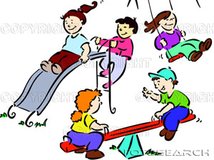

Dealing with Bullying

In any cases of bullying in the school, sanctions will include:
- Withdraw the child from the situation and discuss with them why they have been withdrawn.
- Encourage the child to say sorry to the victim.
- Direct the child to a different activity.
- For more serious behaviour, thinking time on a chair but no longer than 3 or 4 minutes.
- For more serious behaviour, parents/ guardians will be involved.
- If it is a particularly serious case of bullying it could lead to a Child Protection Issue and this will be dealt with accordingly.

Links with other School Policies:
This policy has links with our Complaints Procedures and Policy so that parents/ guardians know what to do if a child is being bullied. It also has links with our Pastoral Care, Child Protection and Positive Behaviour Policies.

Monitoring and Review of the Policy:

This policy will be reviewed annually by the staff and Principal of Drumnamoe Nursery School.

